# Management 435 New Product Development Reading

# Marketing Math Essentials

## Section 1: Introduction

* Three challenges for applying these ideas
  + Gathering relevant and reliable data
  + Knowing when to use which calculation and why
  + Knowing what to conclude from the results

### Inputs for calculations

* Good analysts and managers are always mindful of the quality of the inputs

#### Four types of inputs

##### Hard numbers

* Costs, margins, market shares, size of customer bases, and other data that are reliably measured
* Other hard numbers can result from a combination of
  + Marketing research
  + Econometric modeling
  + Managerial judgment
* Hard data must be carefully scrutinized.
  + Cost and margin are affected by how indirect costs are allocated across products and business lines
  + Market research must be approached with a critical eye

##### Company/industry averages

* Well-established averages that are typical for the company or the industry
* Useful but should be adjusted to fit the current product and situation

##### Educated guesses

* Based on common beliefs or professional experience
* May be based on experience with a specific product or market
  + But typically come from more general experience

##### Wishful thinking

* Wishful thinking and other unsubstantiated inputs should not be used except in sensitivity analyses
* Have no basis in reality are often used to make marketing objectives look achievable, regardless of their true merit
* It is sometimes useful to work backwards from bottom line objectives to the inputs required to achieve them.
  + Unless the objectives are explicitly recognized as goals rather than facts, these derived inputs must again be carefully scrutinized and defended as realistic

### A word of advice

* In reporting the results of quantitative analyses, the sources of input data should be explicitly cited, and any assumptions that were used to generate or adjust the inputs should be explicitly stated and justified. The latter is especially important

## Section 2: When to use which calculations and why

* Six types of calculations
  + Margin analysis
  + Break-even analysis
  + Chain models of segment value
  + Customer lifetime value
  + Economic value to the customer
  + Weighted cost-per-thousand

### Margin

* When
  + Always
* Why
  + To locate the profit pools in the product line
  + Understand the incentives of competitors and collaborators
  + Margin analysis tracks through the value chain for every relevant product within the firm’s product line and across competitors
    - Price
    - Variable costs
    - Profit margins
  + Provides inputs for break-even analyses, calculations of segment value, and customer lifetime value, and economic value to the customer
  + Knowing profit margins
    - Help predict the responses to actions the firm may take
  + Knowing the profit margins of competing products
    - Help predict how much marketing support they will receive and how much room there is for their price to be cut

### Total Break-Even Unit Volume

* When
  + When proposing or evaluating a marketing plan
* Why
  + To assess whether a plan is profitable given its expected sales volume
  + Is most useful when good estimates of sales volume are not available, but managers feel comfortable assessing whether a particular sales volume is attainable or not
  + Especially valued by entrepreneurs and new venture managers facing great uncertainty about demand

### Incremental Break-Even Unit Volume

* When
  + When considering a marketing action or change in policy
* Why
  + To show that the action will generate sales and margins that are sufficient to cover the cost of the action
  + The objective to calculate the number of units that must be sold for a new marketing action or a change in policy to be profitable
  + The difference between incremental break even and total break even
    - Incremental focus on the change in sales that is required for the action to be profit-neutral if that action entails a change in the margin and/or the fixed costs

### Break-Even Cannibalization Rate

* When
  + When introducing a new product into an existing product line
    - Cannibalization occurs when a new product added to the product line steals sales away from existing product in the line
* Why
  + To show that the profitability of the product line as a whole will not suffer as result of the proposed action
  + The highest acceptable cannibalization rate
    - Introducing the new product is supported to the extent that there is evidence that the actual cannibalization rate will be lower than the BECR

### Chain Models of Segment Value

* When
  + When making decisions about which market to target
* Why
  + To understand the size and financial value of market segments

### Customer Lifetime Value

* When
  + Whenever single transactions do not represent the value of customers to the firm
  + CLV analysis is valuable when one or more of the factors are present

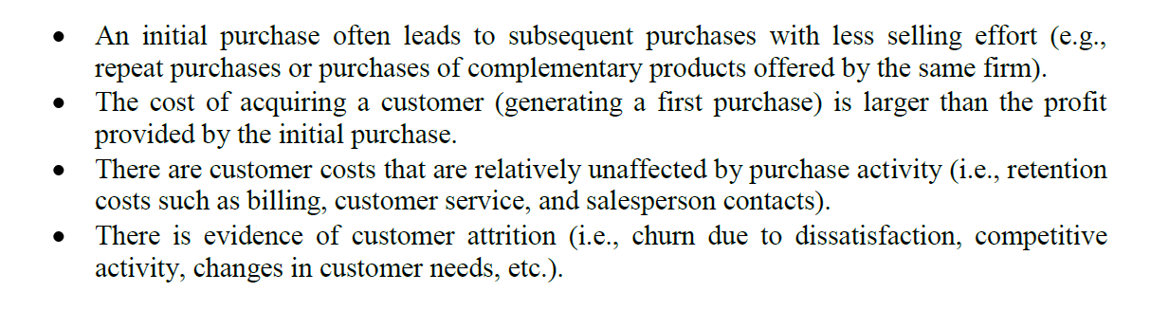

* Why
  + To estimate the present value of a customer who will generate a stream of revenue and costs over a relatively long period of time
  + CLV answer the question
    - How much can we spend to acquire this type of customer and remain profitable?
  + Provide a basis for deciding which segments to target based on long-term profitability
    - Determine whether it is more profitable to acquire new customers or to better serve current customers
    - Forces managers to think about how sales are generated as well as maintained
  + Positive CLV
    - Marketing actions will more than break-even over the lifetime of the customer

### Economic Value to the Customer

* When
  + Whenever a major benefit of the product is to save the customer money in the long-run even though the initial price of the product may be higher than that of a competitor
    - Capture how much value the product provides to the buyer over its lifetime compared to the value provide by competitive offerings
* Why
  + EVC is used to determine a given customer’s willingness to pay, and to quantify economic or financial reasons for that customer to buy the product.
  + The former sets a ceiling for the price, and the latter is useful for developing messages in sales pitches, advertisements, and other marketing communications
  + The actual price must be lower than the EVC
    - The EVC is the price at which the value of a firm’s product to the customer is exactly equal to the value of a specific competitive product

### Weighted Cost-Per-Thousand

* When
  + Whenever different media options deliver audiences that differ in their composition
    - Geographically
    - Demographically
    - Psychographically
  + wCPM is particularly useful when the media are similar in format and advertising persuasiveness, but reach somewhat different audiences, and segmentation data is available for each media option
* Why
  + To determine the cost effectiveness of each option given the firm’s market segmentation strategy
  + The calculation reveals the cost of a media vehicle per thousand people reached with the vehicle
    - Adjust the media cost for the differences in audience size across media options
    - One needs to use the wCPM to adjust the cost for reaching customer segments actually targeted by the firm
  + If media options are similar
    - The option with lowest wCPM is usually chosen
  + If media options have significant qualitative differences that affect how customers will respond
    - The differences in wCPM quantify the price premium that is being paid for those qualitative differences

## Section 3: Margin Analysis

* A table that tracks prices, variable costs, and profit margins through the value chain for every relevant product within the firm’s product line and across competitors
  + Inputs for break-even, segment value, CLV, and EVC analyses.
  + Knowing profit margin for channel member and competitors helps predict their response to actions the firm may take
* Definitions for the components of a margin analyses

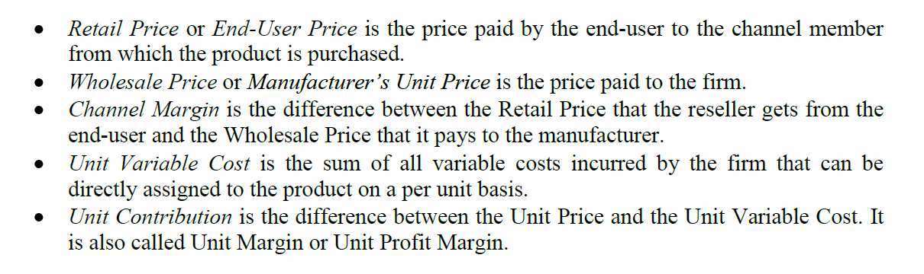

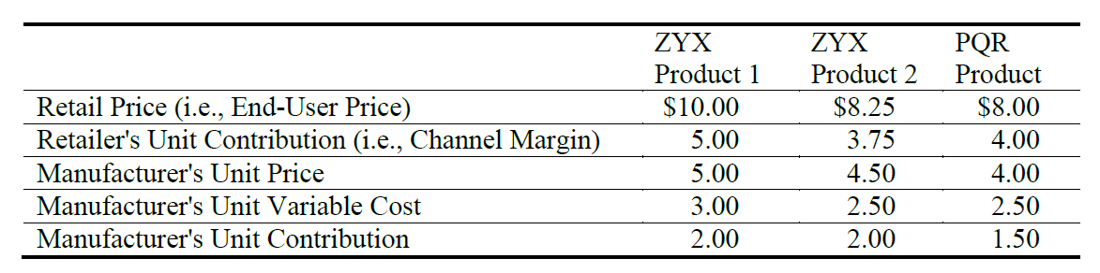

## Section 4: Break-Even Analysis

* Identify what level of sales is necessary for you to just recover you costs and break-even profit wise
* Useful when good estimates of sales volume are not available, but managers fell comfortable assessing whether a particular sales volume is attainable or not
* Simple tool to separate the potential winners form the definite losers and manage risk when developing marketing plans
* Break-Even analysis is the first step in the evaluation of an action or plan
  + But not sole criterion for a decision
* Total break-even analysis
  + Help you identify what minimum level of sales is necessary for the plan to be profit-neutral
* Incremental break-even analysis
  + Is used when considering changing an existing marketing strategy
  + Identify the change (incremental or detrimental) in sales that is required for the action to be profit-neutral if that action entails a change in the margin and/or the fixed costs
* Break-even cannibalization rate
  + An application of the general break-even logic when considering adding a new product into an existing product line

### Total Break-Even Unit Volume

* The total break-even unit volume is the point at which total profit is exactly zero
  + A zero total profit implies that Unit Volume x Unit Contribution = Total Fixed Cost
* In some cases, the fixed costs affect several products and are not allocated to each of them separately
  + You have to compute an average unit price and an average unit variable cost for the entire set of products
  + In computing, it is important to use weighted averages rather than simple averages because different products will achieve different levels of sales
    - To compute the weight average unit price
      * Divide total revenue from all products by the total number of units sold
    - To compute the weighted average unit variable cost
      * Total variable costs for all products can be divided by total unit volume

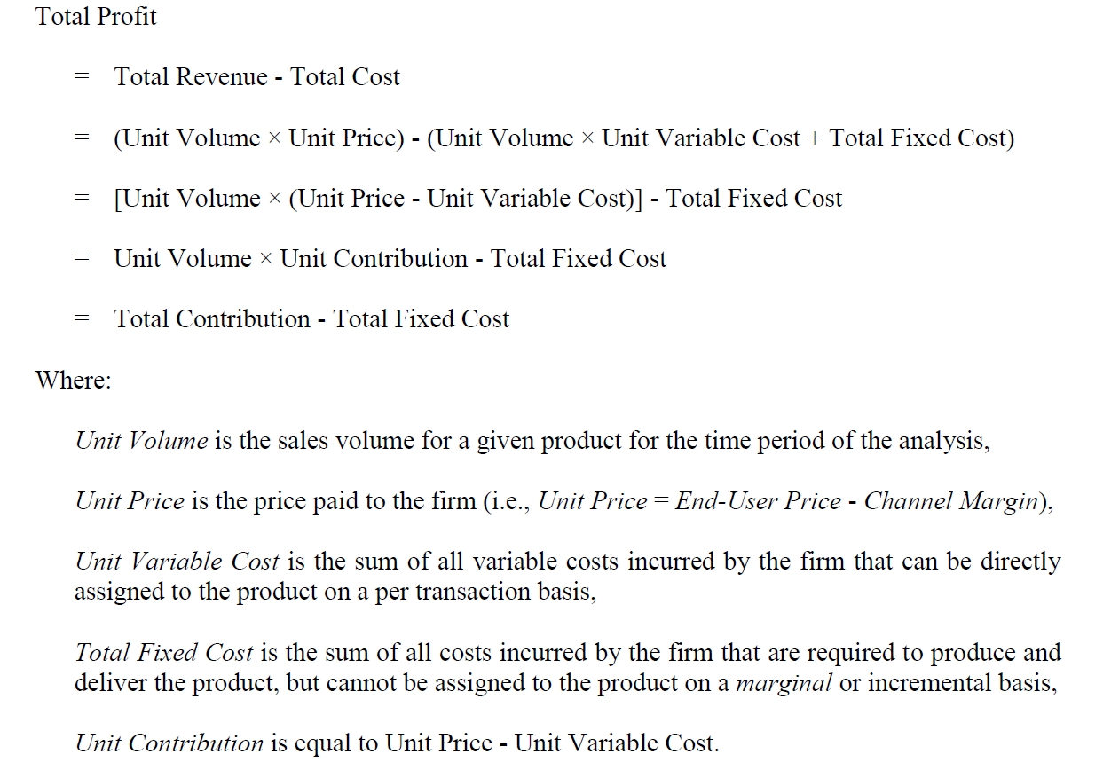

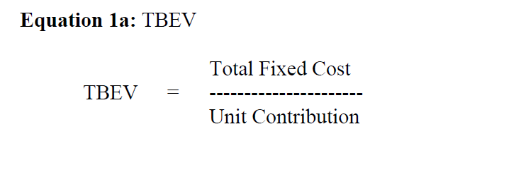

### Incremental Break-Even Unit Volume

* It can be applied to many decisions
* Separate formulas for cases where the change in policy generates changes in the fixed costs and for cases where it generate a change in margins
* IBEV for fixed cost actions
  + Typical fixed cost action included
    - Advertising expenditures
    - Investments in production capacity
    - Training and salaries for sales force
  + 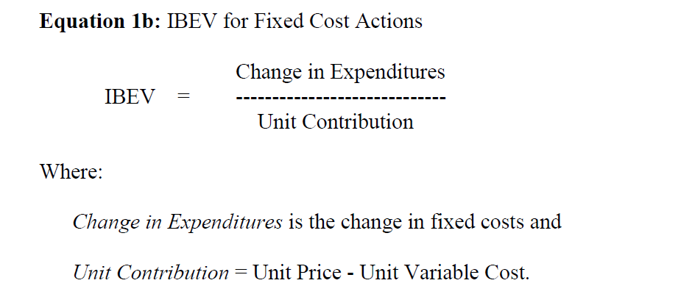
* IBEV for actions that change unit contribution
  + Typical actions that change unit contributions include
    - Price cut
    - Price increase
    - Product reformulations generating higher or lower variable costs
  + 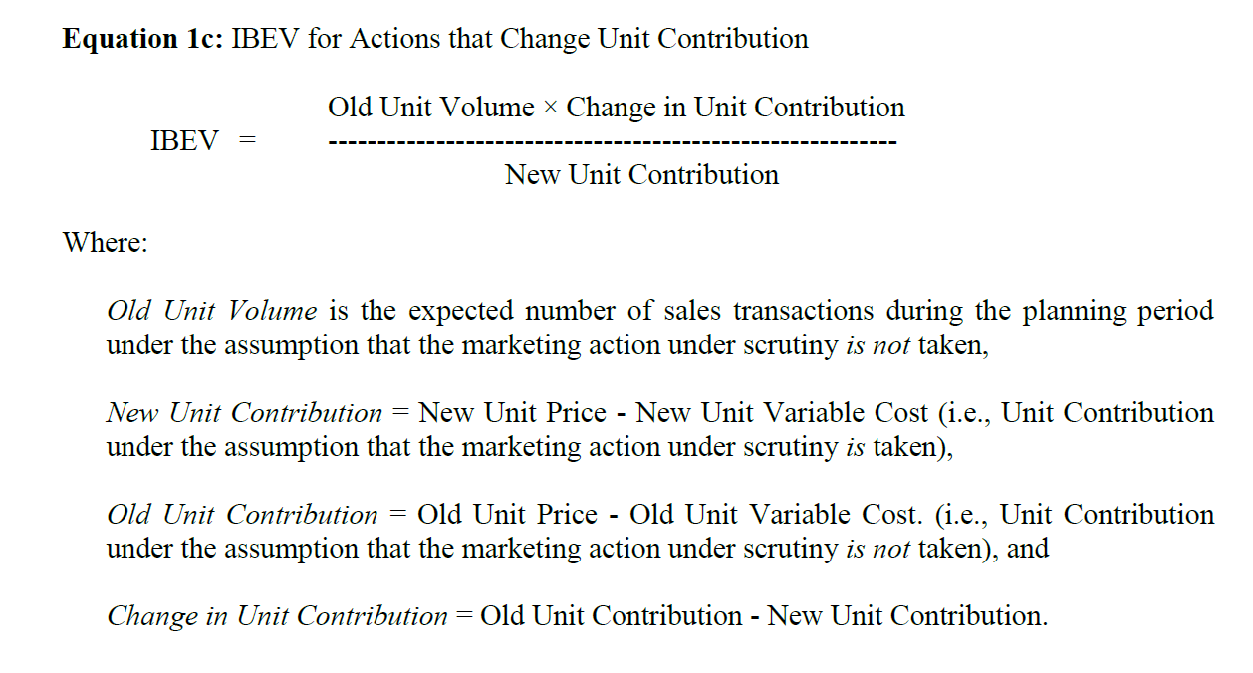
* IBEV for actions that change both fixed costs and unit contribution
  + 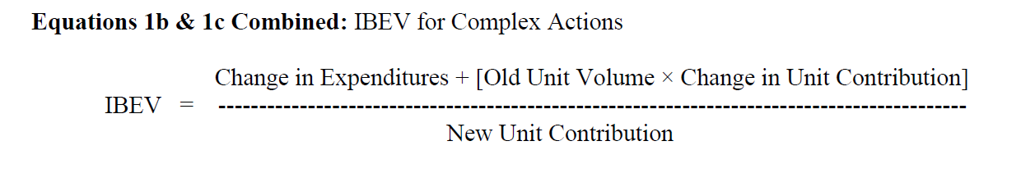
  + 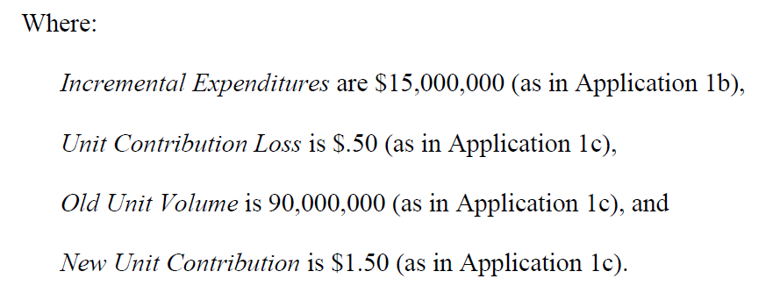

### Break-Even Cannibalization Rate

* Whenever a marketing action for one product in the product line may steal sales away from other products in the line, cannibalization must be considered
* The cannibalization rate is the fraction of sales of the new product that is stolen from the old product
* 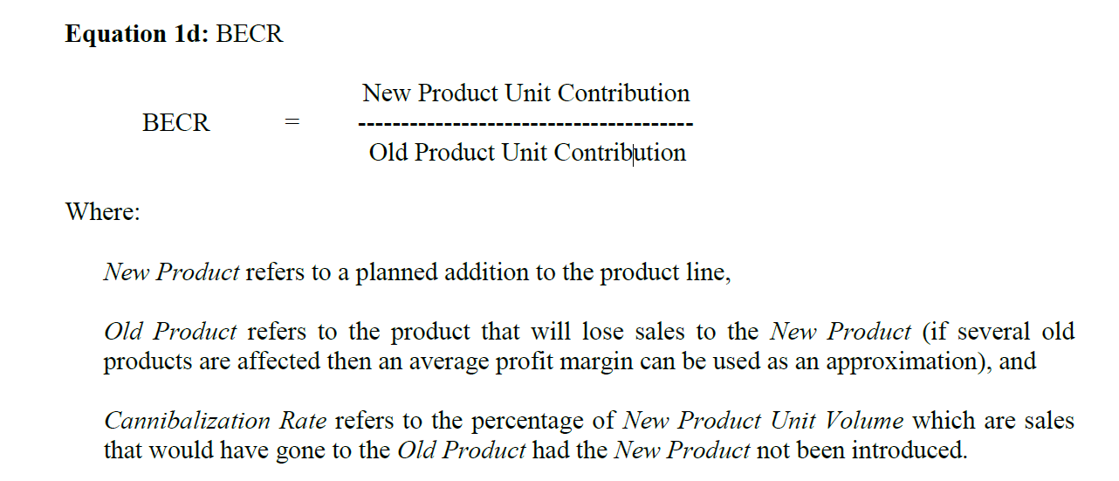
* A large BECR is good
  + The actual cannibalization rate must be lower than the BECR in order for the new product introduction to be profitable
  + When the new unit contribution is larger than the old unit contribution, the BECR is greater than 100 percent.
* 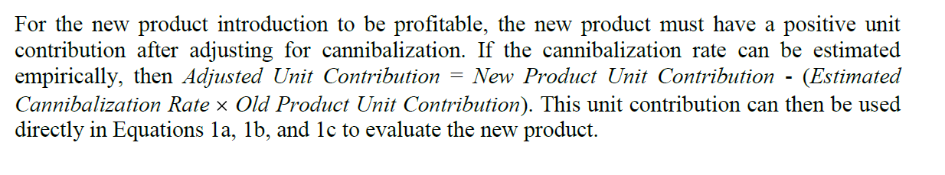

## Section 5: Chain Models of Segment Value

* The basic idea of chain model is to estimate the number of customers by starting with the most general population and reducing it according to segment characteristics
  + This yields the potential segment size
  + To compute the segment size, current penetration rates are applied
    - How many customers use the product or a competitor’s product now
    - Because most marketing plans and budgets have a one-year time horizon, annual figures are most commonly used when sizing and valuing segments
  + Chain model
    - A series of terms are multiplied together
    - The number of term varies, depending on the situation and the information available
* 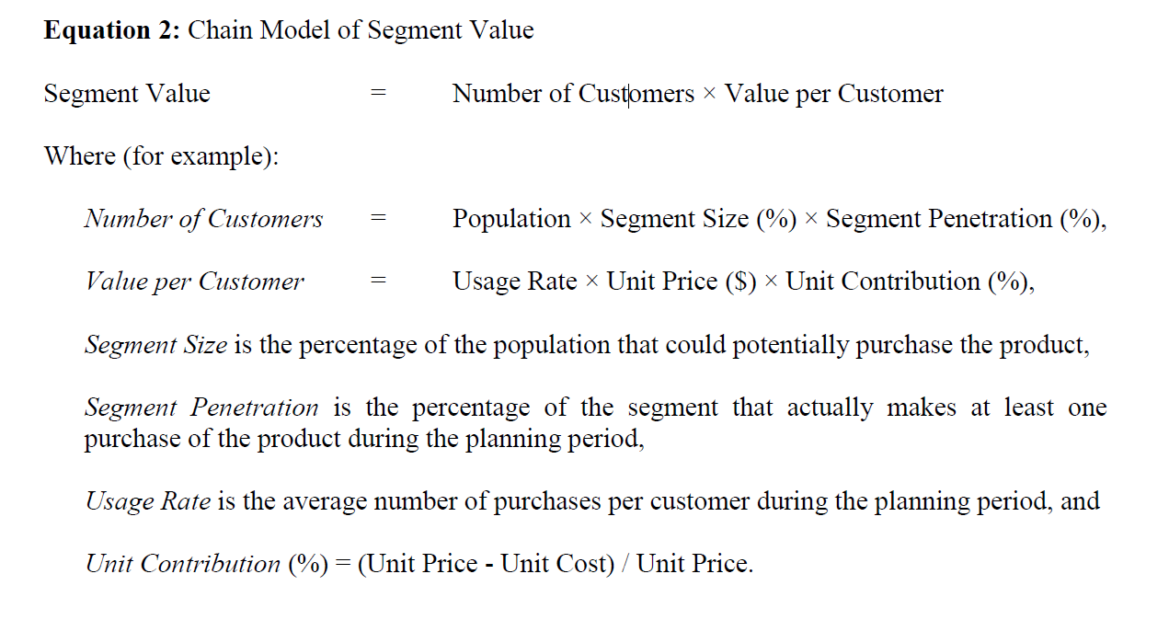

## Section 6: Customer Lifetime Value

* Marketing strategies focus on the financial value that customers provide over time for three important reasons
  + The increasing focus on customer-oriented, market-driven business strategies demands a longer term perspective
  + Advances in marketing research and information technology have allowed managers to micro-market and data mine at the level of very small segments or even individual customers
  + Increasing emphasis on making marketing more accountable has stimulated marketers to justify investments of the value of customers over time in order to demonstrate their contribution to profitability
* Experience with CLV calculations is most advanced in industries where
  + Purchases are reasonably frequent
  + Input data is readily available
  + Important marketing decisions are based on individual customer’s expenditures over time
* CLV can be used to
  + Devise marketing programs that are tailored to preferences and behaviours of target customers
    - i.e. Loyalty card
  + Assess the present value of a customer over some time frame
    - A financial metric that measures the value of a customer based on revenues generated over time, discounting those revenues to take into account the cost of capital
  + Access costs to generate revenues from customers over time
    - This is because calculating CLV requires the marketer to specify costs to acquire and retain customers
    - CLV might signal that either or both of these costs are too high
    - Marketer could conclude that the CLV is high enough to warrant even more expenditures to acquire and/or retain customers
  + Assess brand loyalty, since another measure required to calculate CLV is the retention rate
    - What proportion of our customers continue to buy our product from year to year
* 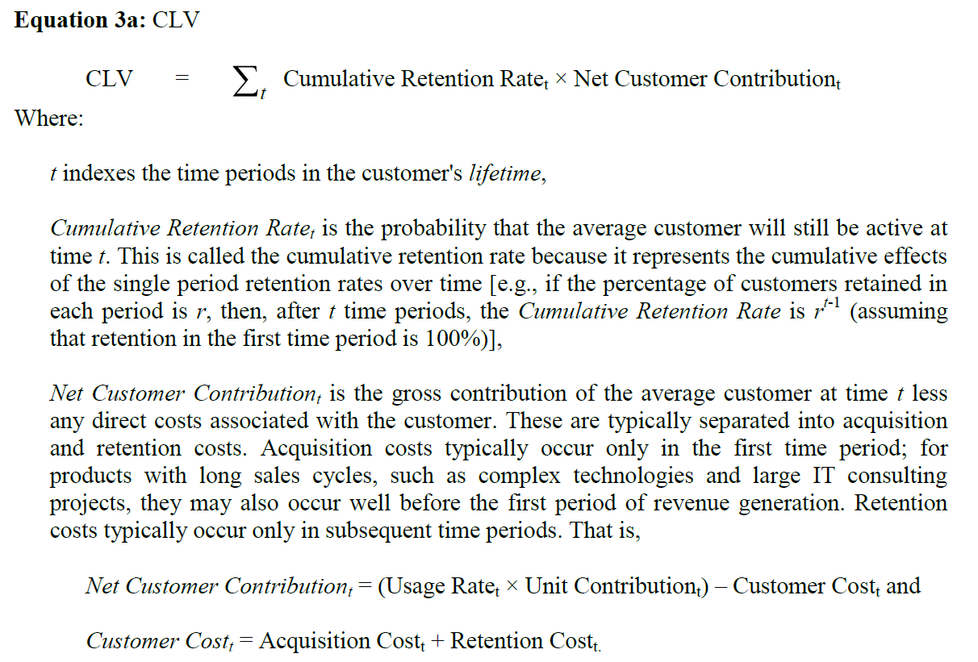
* 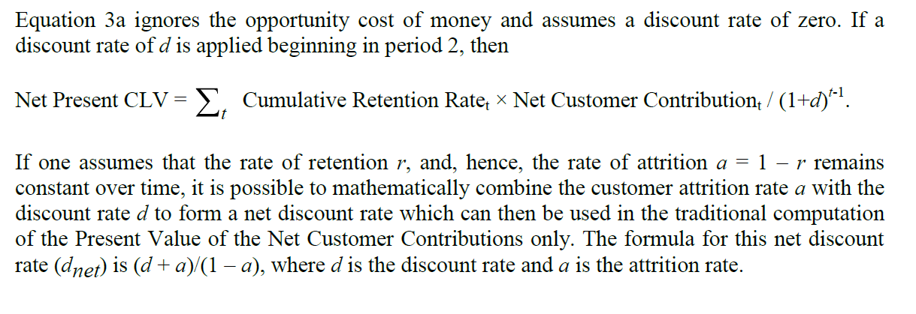
* 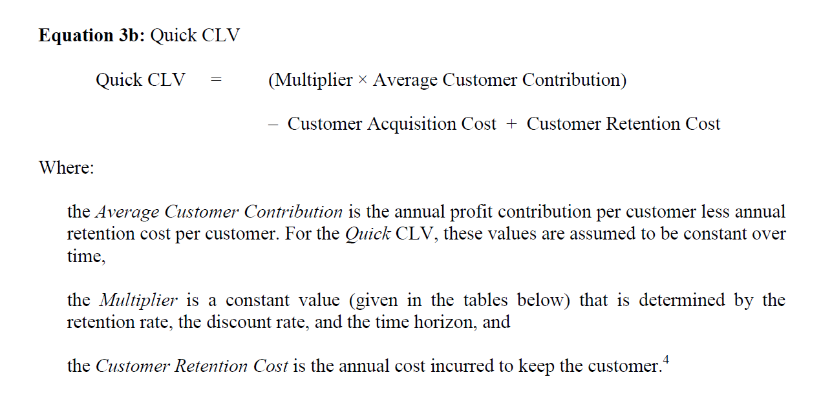
* 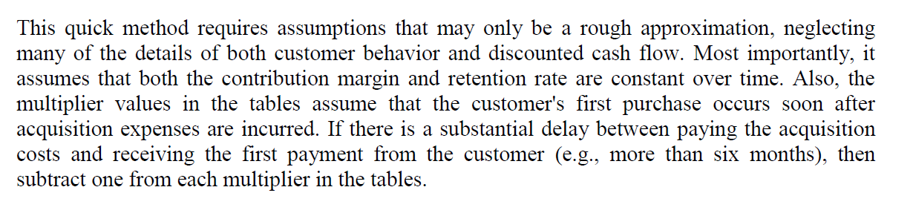

## Section 7: Economic Value to the Customer

* Just a forward-looking firms consider the lifetime value of their customers, customers often examine the lifetime value of the goods and services that they consider purchasing
* In marketing products that are designed to reduce the customer’s costs or to add value over a long time period, it is important to quantify lifetime value to the customer
* EVC capture
  + How much a customer, aware of all long-term economic benefits, is willing to pay for your product
* EVC is a way to calculate the customer’s reservation price, and the difference between the EVC and the price actually charged is the consumer surplus which provides the customer a reason to prefer your product over those of competitors
* 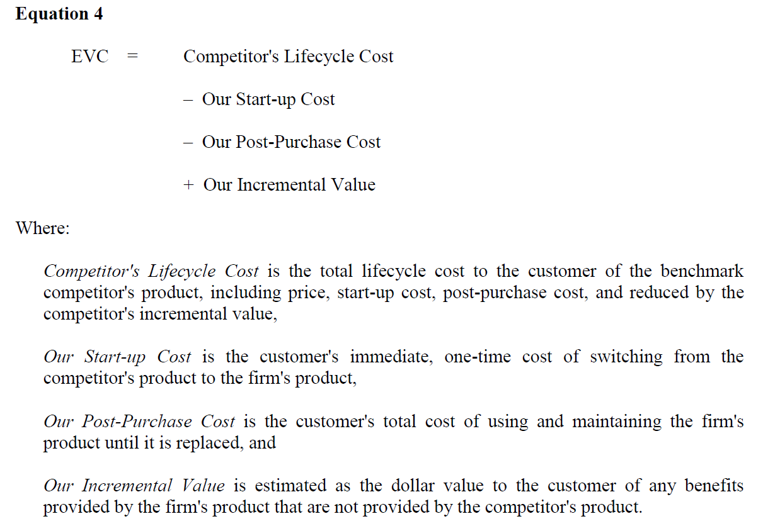

## Section 8: Weighted Cost-Per-Thousand (wCPM)

* It is important to evaluate costs across media options that reach different audiences from the perspective of a specific segmentation strategy
* 